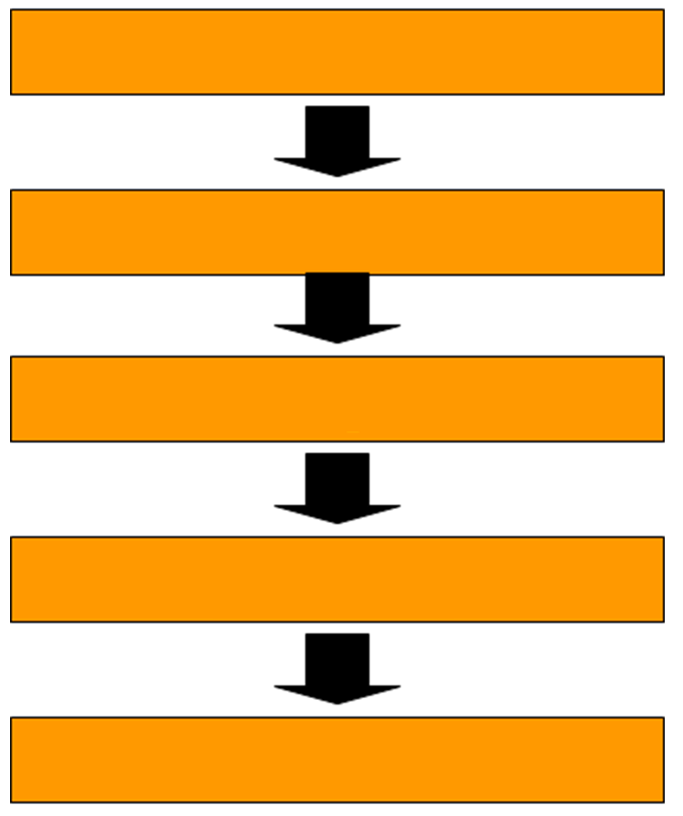

write result

compute

read operand(s)

calculate address

read instruction